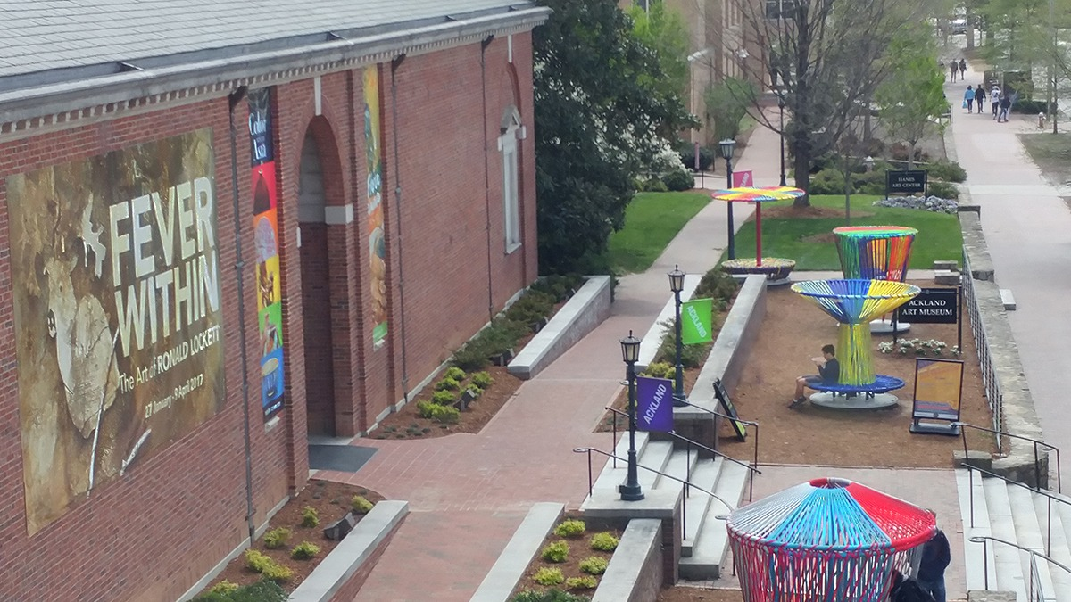

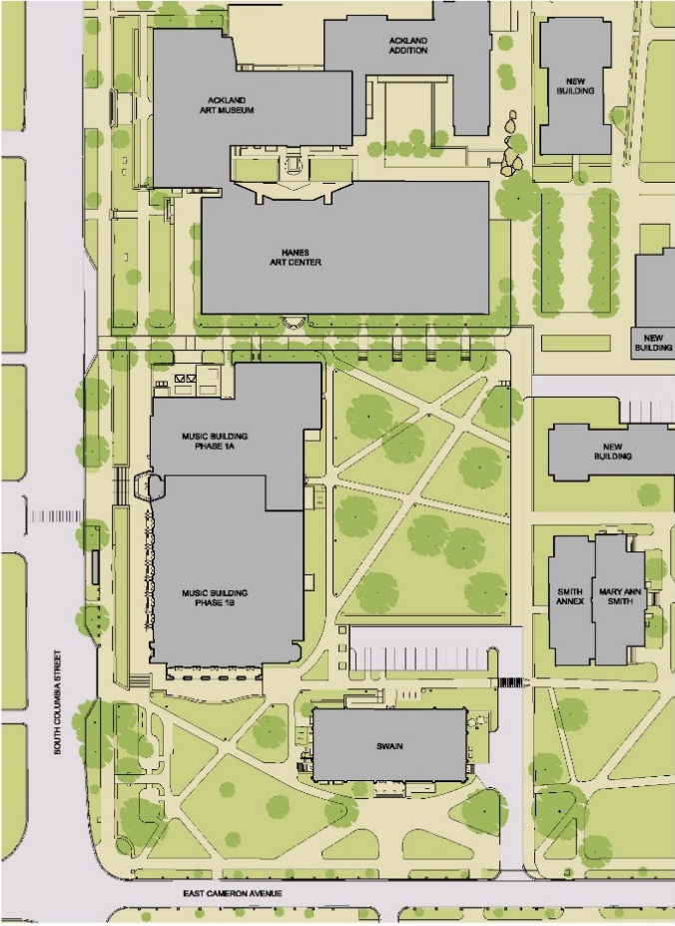

Services Provided:
Ackland Art Museum Expansion
- Provided preliminary civil engineering design services related to utilities and storm drainage.
Music Building
- Water and sewer facilities in highly congested area.
- Water distribution analysis.
- Storm drainage and stormwater management.
- Driveway access issues.
- Erosion control.
- Plan approval with Chapel Hill.
- Construction Administration.
- Parking lot expansion, accessibility issues.
- Storm drainage and erosion control design.
- Relocation of underground utilities.
- Local plan approval assistance with Chapel Hill.
- Water permitting with OWASA and NCDENR Public Water Supply.
- Erosion Control Permitting with NCDENR Land Quality.
- NCDOT driveway permit and encroachment agreements.

UNC Arts Common Complex

Ackland Art Museum & UNC Music Building

Client Reference: Walt Havener, ASLA, Surface 678 (fka Lappas+Havener, PA)

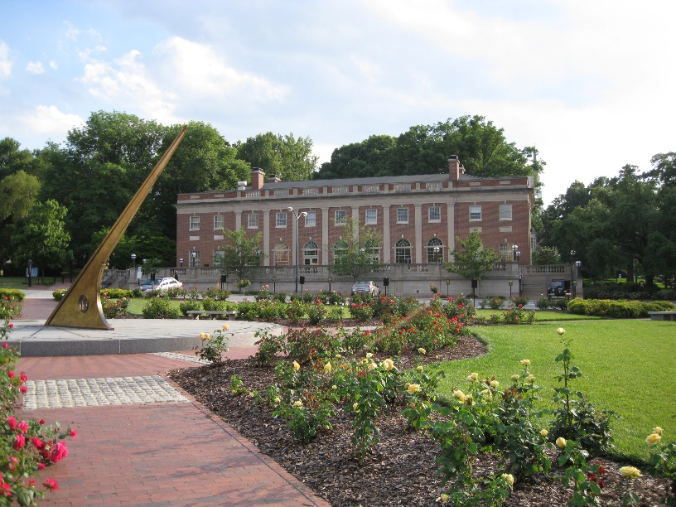

Services Provided:
- Civil Engineering services provided through the project architect.
- Parking lot expansion, accessibility issues.
- Storm drainage and erosion control design.
- Relocation of underground utilities.
- Local plan approval and permitting from the Town of Chapel Hill and OWASA.

Graham Building Addition

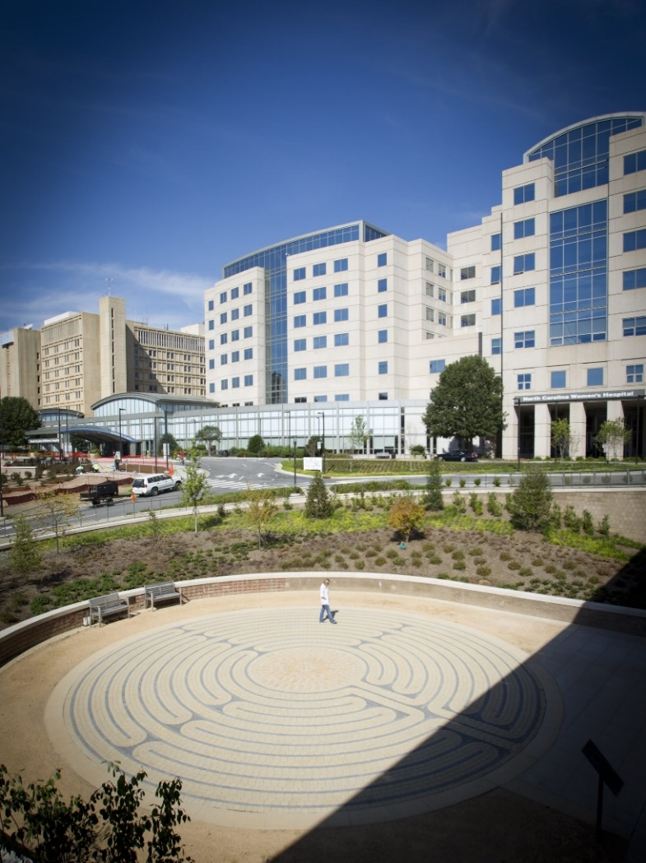

Services Provided:
- Civil engineer for $43 million, nine story, 250,000 s.f. facility.
- Facility includes research laboratories, expanded inpatient and outpatient clinics for neurology, microsurgery and otolaryngology.
- Civil design included utilities, parking lot, new access road on Manning Drive, and storm water management for 15-acre site.
- Performed inventory, mapping and analysis of existing storm drainage system.

North Carolina Neurosciences Hospital
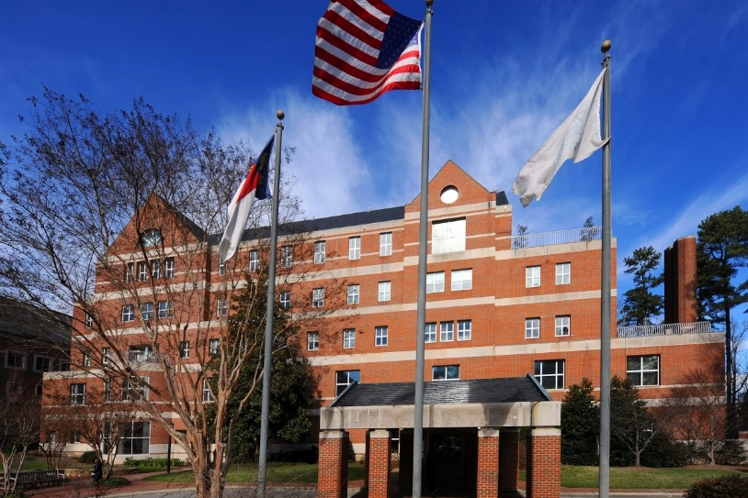

Services Provided:
- Civil engineering consultant for schematic design through construction administration.
- Surveying consultant.
- 65,000 sf institutional classroom, conference and office facility overlooking Student Activity Center site.
- Civil sitework design of 2,100 lf access drive, water, sewer, parking, storm drainage and retaining walls
- 80 parking spaces.

The Kenan Center

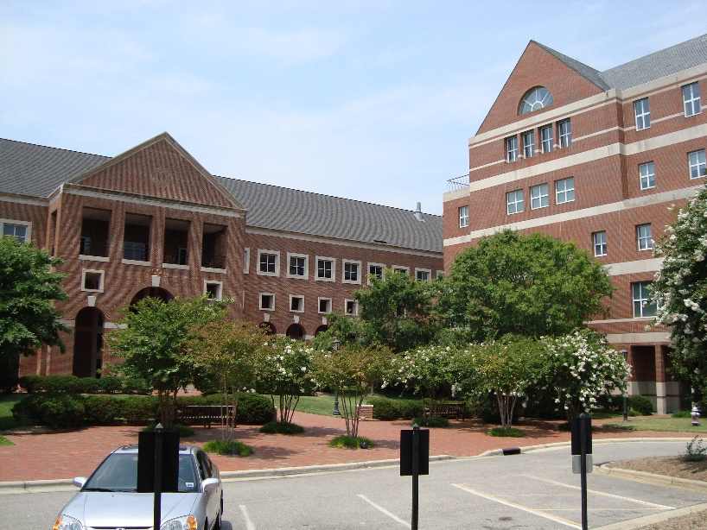

Services Provided:
- Consulting civil engineer and project surveyor.
- Sitework for 160,000 sf classroom and office facility.
- Civil design work of water, sewer, storm drainage, horizontal layout, structural design of retaining walls.
- Pedestrian link to the proposed 500 space parking deck.
- Field work, computations, coordination with utility services and drafting necessary to prepare a topographic survey of 8 acres showing underground utilities, trees and boundary lines.

The Kenan-Flagler School of Business

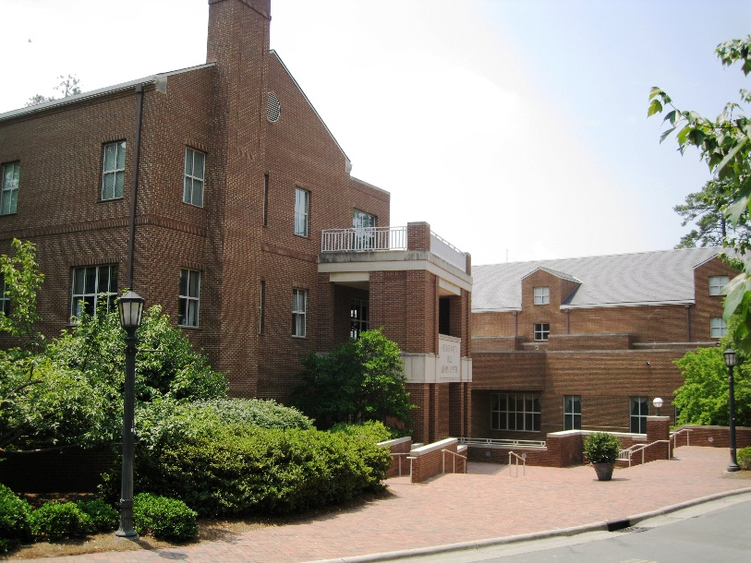

Services Provided:
- Civil engineering and surveying consultant.
- Sitework design for 63,000 s.f. combination meeting, social and administrative facility on UNC-CH Campus.
- Civil design of access and service drives, water and sewer, storm drainage parking improvements, chilled water, steam and condensate lines.

The George Watts Hill Alumni Center

