Client: National Heritage Academy
Contact: Jeff Chamberlain, Director of Real Estate
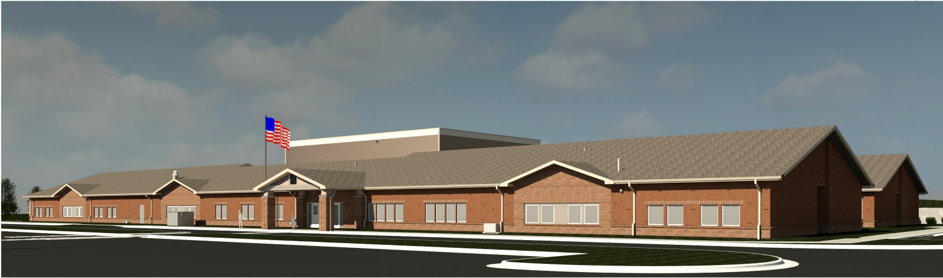

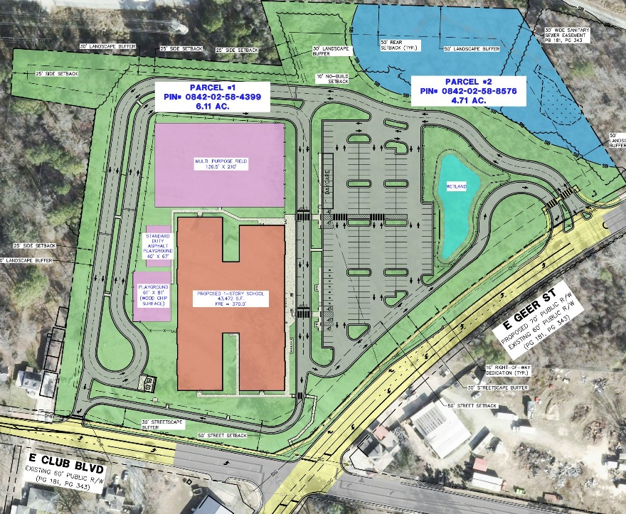

Oak Charter Academy Features
- 10.6-acre site.
- 772-student (K-8), 43,500 sf charter school.
- ±4,300 lf queuing length for drop-off/pick-up.
- Playfield & playground.
- On-site stormwater management (stormwater wetland).
- Off-site roadway improvements on E Club Blvd and E Geer St.

Services Provided:
- Civil site design and surveying.
- Coordination of traffic engineering and queuing design (by WadeTrim).
- Design of off-site roadway improvements.
- Coordination of all approvals from City of Durham:
  - Annexation
  - Site Plan
  - Major & Transportation Special Use Permits
  - Construction Plans/Permits
- Coordination of Durham County Approvals
  - Land Disturbance Permit
- Coordination of NCDOT Approvals
  - Driveway Permit & Encroachment Agreements
- Approvals obtained on time.
- ALTA/Boundary and topographic surveys.
- Recombination & easement plats.

